

FIT5047 Intelligent Systems

Lab Assignment 1

Jaimon Thyparambil Thomas

Student ID: 29566428

Email: [jthy0001@monash.student.edu](mailto:jthy0001@monash.student.edu)

Nikhil Suresh

Student ID:

Email:

**Question 1**

Expand the Bayes Net you developed in the BN tutorial (available on moodle under the name SmokeAlarm.dne) to include three more events: Smoke (you can see smoke in your apartment), Evacuation (your apartment building is evacuated), and Report (the local newspaper writes a report about the evacuation of your apartment). The probability of smoke when there is fire is 0.9, the probability of smoke when there is no fire is 0.01. When your apartment building has a fire alarm, there is a 0.88 probability that there will be an evacuation, but there is never an evacuation when there is no fire alarm. If there is an evacuation, there is a 0.75 probability that the newspaper will write a report on it, and if there is no evacuation there is a 0.99 probability that the newspaper won’t report it.

(a) Add the necessary nodes and edges to your BN, and input the corresponding conditional probability tables. Justify your expanded network and CPTs. A BN without justification will receive no marks.

|  |  |
| --- | --- |
| P(Fire) = T | P(Fire) = F |
| .01 | .99 |

|  |  |
| --- | --- |
| P(Tampering) = T | P(Tampering) = F |
| .02 | .98 |

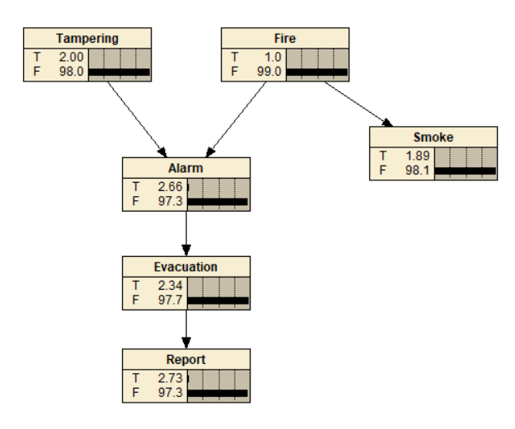

Figure 1

**Alarm**

|  |  |  |
| --- | --- | --- |
|  | P(Alarm = T |Tampering,Fire) | P(Alarm = F |Tampering,Fire) |
| Tampering = T, Fire = T | 0.5 | 0.5 |
| Tampering = T, Fire = F | .85 | .15 |
| Tampering = F, Fire = T | .99 | .01 |
| Tampering = F, Fire = F | 0 | 1 |

**Smoke**

|  |  |  |
| --- | --- | --- |
|  | P(Smoke = T | Fire) | P(Smoke = F | Fire) |
| Fire = T | 0.9 | .1 |
| Fire = F | .1 | .99 |

**Evacuation**

|  |  |  |
| --- | --- | --- |
|  | P(Evacuation = T | Alarm) | P(Evacuation = F | Alarm) |
| Alarm = T | 0.9 | .1 |
| Alarm = F | .1 | .99 |

**Report**

|  |  |  |
| --- | --- | --- |
|  | P(Report = T | Evacuation) | P(Smoke = F | Evacuation) |
| Evacuation = T | 0.75 | .25 |
| Evacuation = F | .01 | .99 |

(b) Use Netica on the expanded BN to answer the following questions:

i. What is the marginal probability that your smoke detector has been tampered with?

Solution: From Figure 1 it is clear that there is only 2% chance that out smoke detector has been Tampered.

ie Pr(Tampering = T) = 0.02

ii. What is the marginal probability that there will be a news report tomorrow?

Solution: From Figure 1 it is clear that there is only 2.73% chance of a news been reported tomorrow

ie Pr(Report = T) = 0.0273

iii. Let’s assume that you have observed that there is smoke in your apartment. What is the posterior probability that there will be a news report tomorrow?

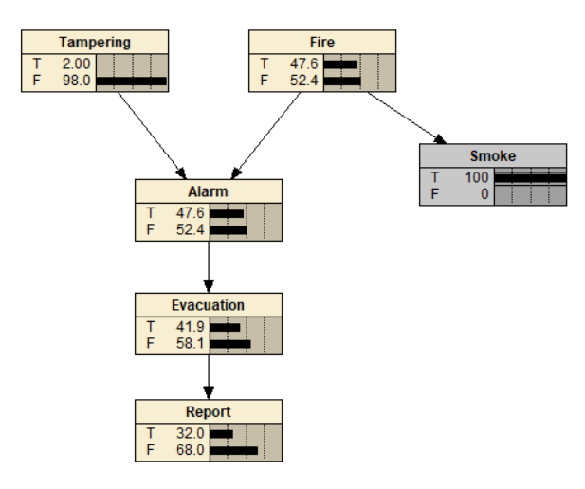

Solution: From Figure in the left it is pretty much clear that if there is smoke in the apartment there is a chance of 32% for the news been reported.

ie Pr(report=T|Smoke = T) = 0.32

iv. Let’s assume that you have observed that there was no fire, and that there was a news report about your apartment. What is the posterior probability that your smoke detector has been tampered with?

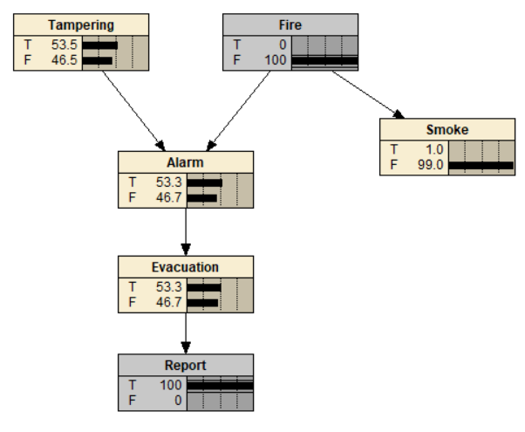

Solution: The posterior probability that the smoke detector has been tampered with given that we have observed that there was no fire and there was a news report about the apartment is 53.5%

ie Pr(Tampering = T|Fire=F,Report=T) = 0.535

v. Let’s assume that you have observed that there is no smoke in your apartment. What is the posterior probability that your smoke detector has been tampered with? What conditional independence property could help you here?

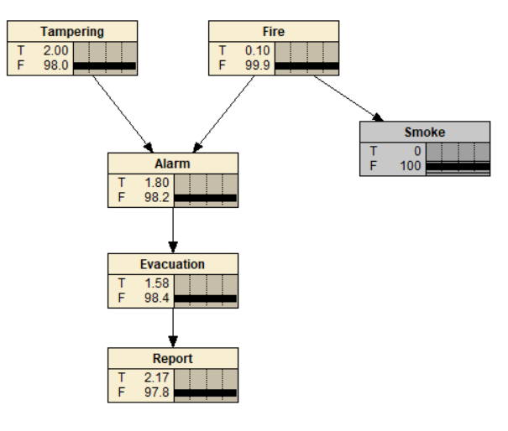

SOLUTION: Even if it is observed that there is no smoke in the apartment. The posterior probability that the smoke detector is been tampered will still be 2% because through the d separation of no common effect both tampering and smoke are independent

Pr(Tampering = T|Smoke= F) = Pr(Tampering = T) = 0.02

vi. Let’s assume that you have observed that there has been a news report about your apartment, and there is no smoke in your apartment. What is the posterior probability that your smoke detector has been tampered with? Given that the news report was observed, why does observing the absence of smoke affect your belief of whether or not your smoke alarm was tampered with?

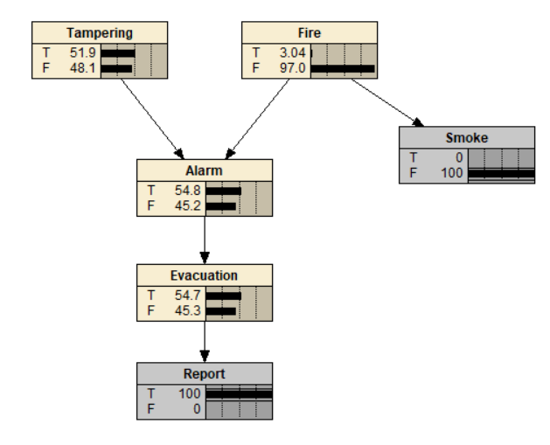

SOLUTION:

Pr(Tampering = T | Report=T, Smoke=F) = 0.519

Observing the value of Report influences the value of Evacuation which influences the value of Alarm. Due to this the value of alarm is been fixed to a certain value. Now the cause of that value are due to fire or tampering. Once the probability of fire is been changed then in-order to maintain the same values of the alarm there is only one option that is to bring change in the value of Tampering in-order to balance the values. The change in value of smoke resulted in change in value of fire. Since now the value of fire is been changed Tampering is also now changed.

Tampering and fire are dependent due to common effect and fire and smoke are dependent since fire is the cause of smoke thus smoke and tampering are dependent in this case

vii. Let’s assume that you have observed that there was no fire, that there was a news report about your apartment, and that there is smoke in your apartment. What is the posterior probability that your smoke detector has been tampered with? How does observing whether or not there is smoke affect your belief of whether or not your smoke detector has been tampered with? Why?

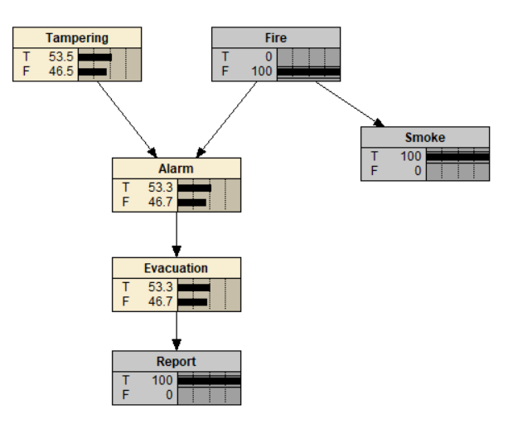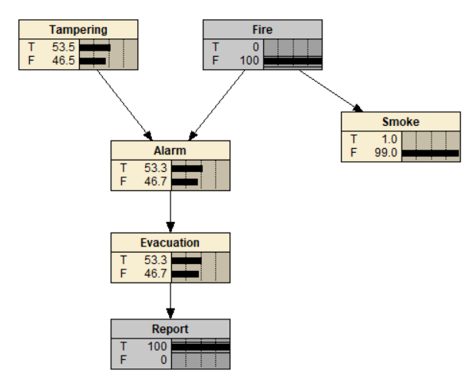

SOLUTION:Pr(Tampering = T|Report = T,Fire = F,Smoke=T) = Pr(Tampering = T|Report = T,Fire = F) = 0.535

From both the figures it is pretty much clear that whether or not there is smoke doesn’t have any influence on tampering because usually the value of smoke affects value of fire which in turn cause any change in Tampering but here already the value of Fire is observed so whatever change we make in smoke won’t affect the value of fire. Since there is no change in the value of fire eventually there won’t be any change in the value of Tampering

Here tampering and fire are dependent due to common effect but since fire is already known smoke and tampering is independent due to chain effect

(c) Hypothesize the (conditional) independence properties of the statements below. Use Netica to check them, and state whether they are true or false. Briefly explain your answers. Answers without explanations will receive no marks.

Note: The graph structure informs us about dependences between variables, but there may be additional dependences based on the values of the conditional probability tables.

Tampering ⊥⊥ Evacuation

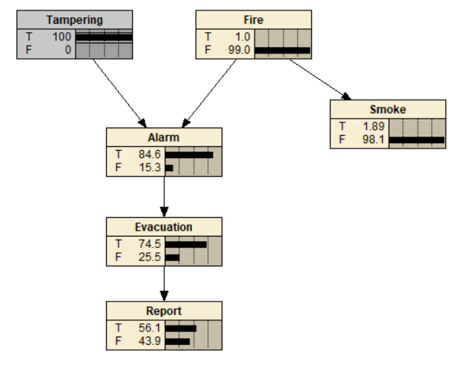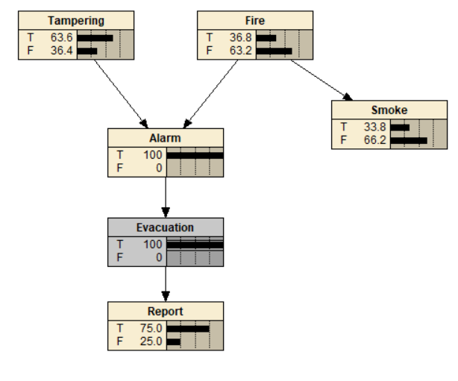

SOLUTION: False, Both Tampering and evacuation are dependent because they are part of the chain. In Netica this statement is been verified as we can see that any change in values of tampering influences change in the value of Evacuation and vice versa.

Tampering ⊥⊥ Evacuation | Alarm

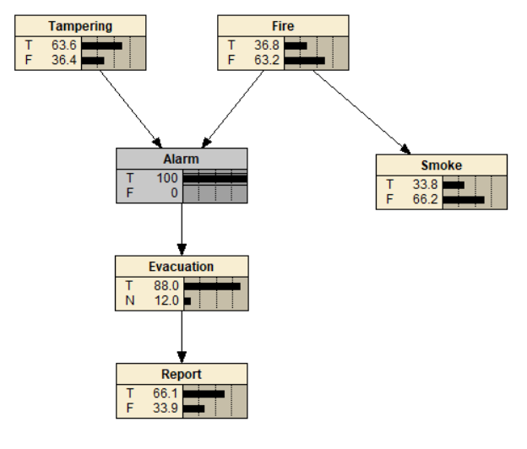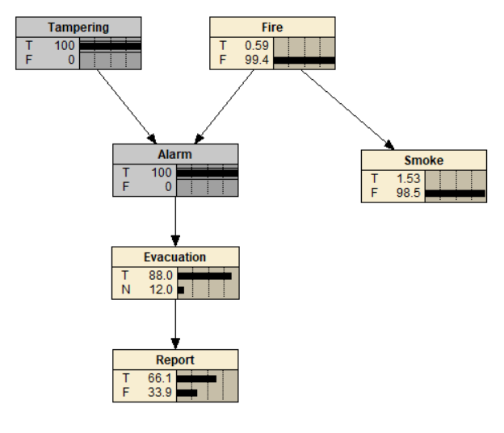

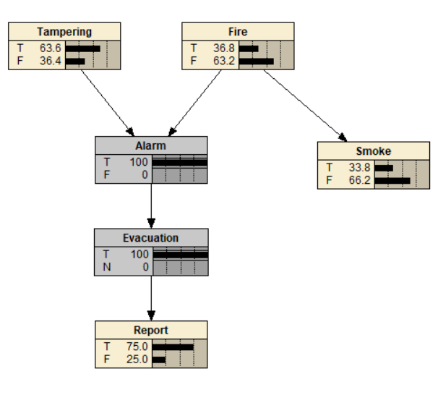

Solution: True, here tampering and evacuation are independent because both are d separated using the chain rule. Using netica we can see that if the value of alarm is known then the value Tampering is independent on the value of evacuation and vice versa

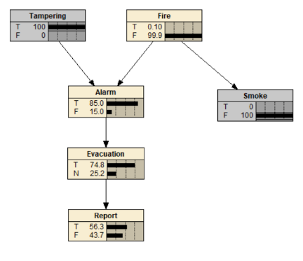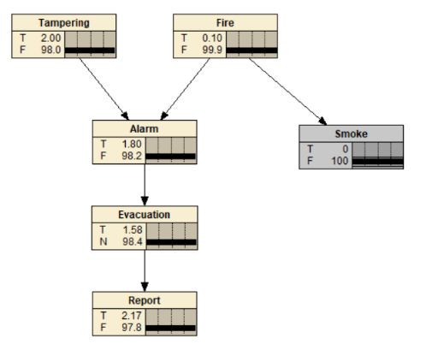 Tampering ⊥⊥ Evacuation | Smoke

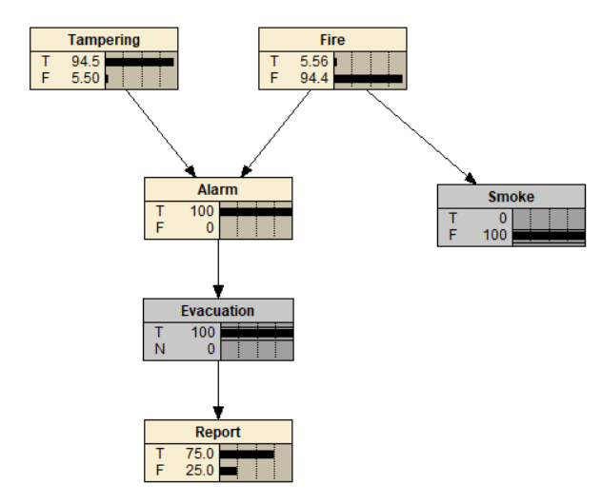

Solution: False, Here Tampering and evacuation are dependent because still now they are part of a chain. Using Netica it has been verified that Tampering is dependent of evacuation even if the value of smoke is given

Tampering ⊥⊥ Fire

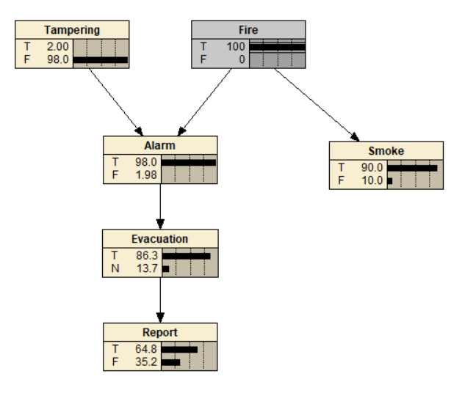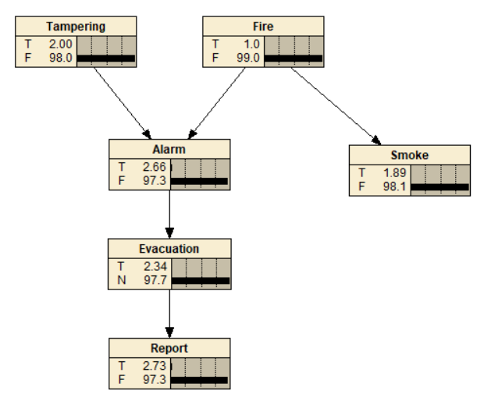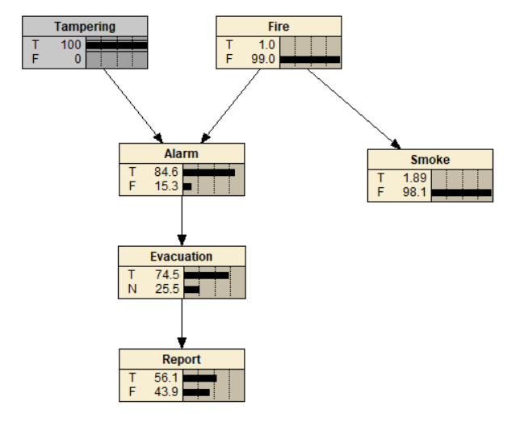

Solution: True, Tampering and fire are independent because no common effect. Using Netica it has been verified that Tampering is independent of Fire as the change in tampering has no effect on Fire

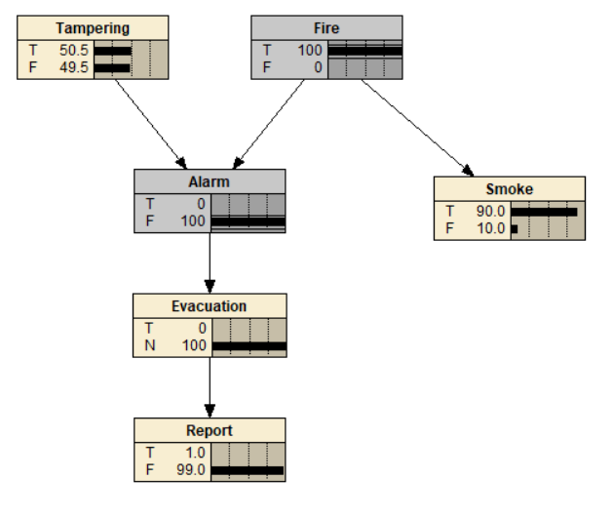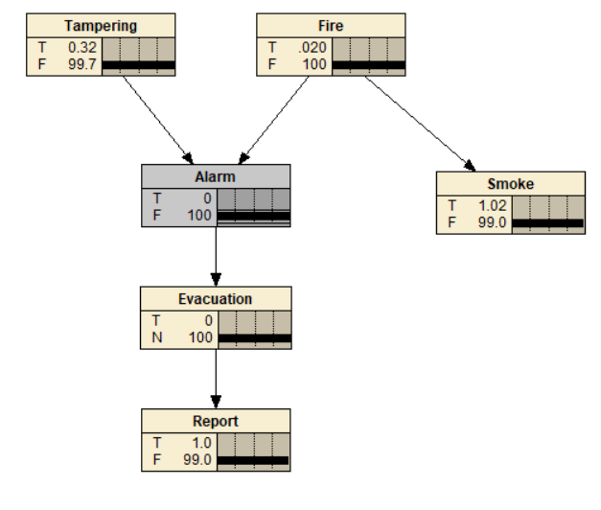Tampering ⊥⊥ Fire | Alarm

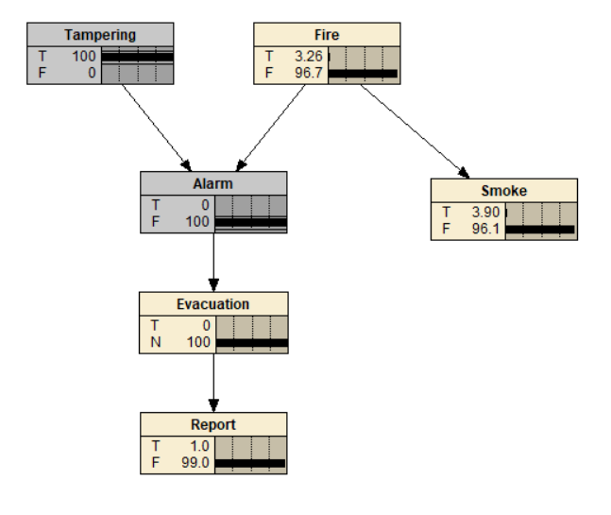Solution: False, Tampering is dependent on Fire now because of common effect. Using Netica it has been verified that any change in Tampering is been propagated to Fire and vice versa.

Alarm ⊥⊥ Smoke

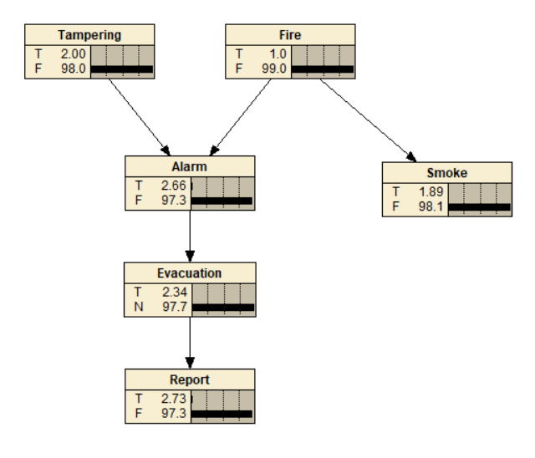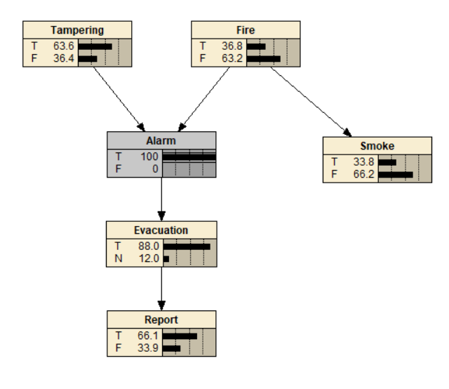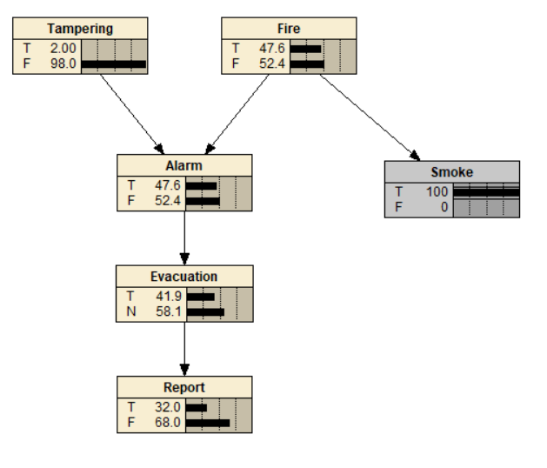

Solution: False, Both Alarm and smoke are dependent to each other because they both have a common cause that is Fire. Using Netica it has been verified that the both alarm and smoke are dependent as any change in alarm is been propagated to smoke and vice versa.

Smoke ⊥⊥ Report

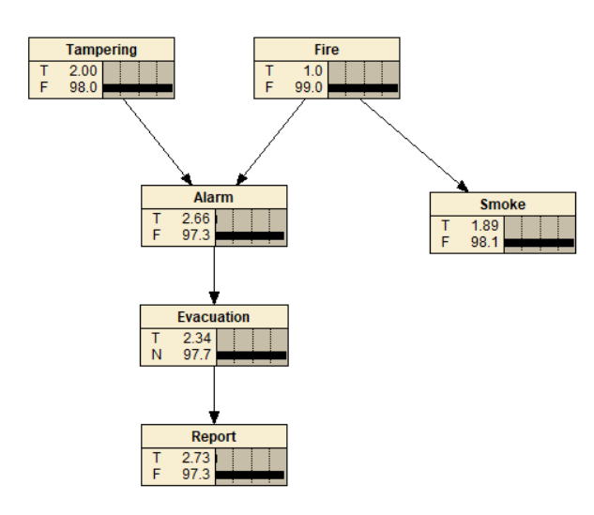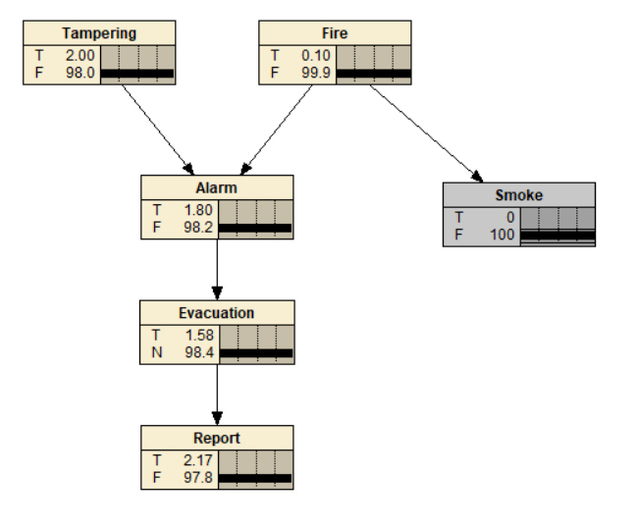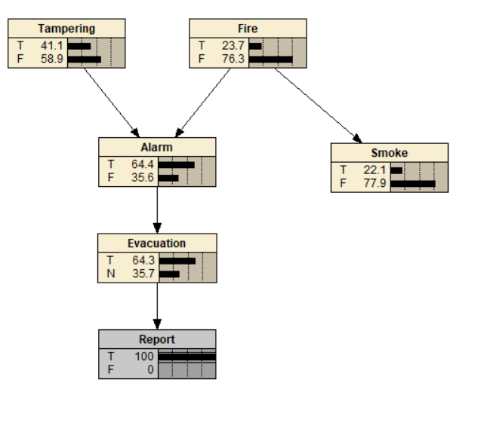

Solution: False, Smoke and report are dependent because smoke and alarm are dependent since they have a common cause fire and alarm and report are dependent as they are part of the chain hence smoke and report are dependent. Using Netica it has been verified that both smoke and Report are dependent as any change in smoke is been propagated to report and vice versa.

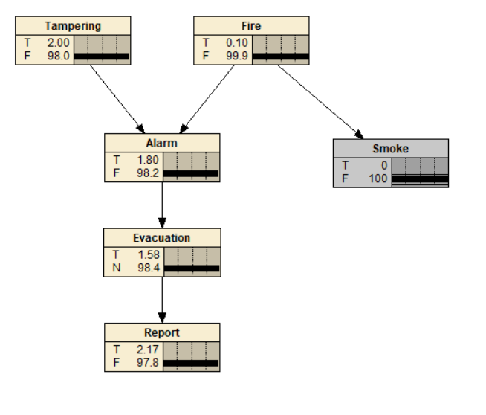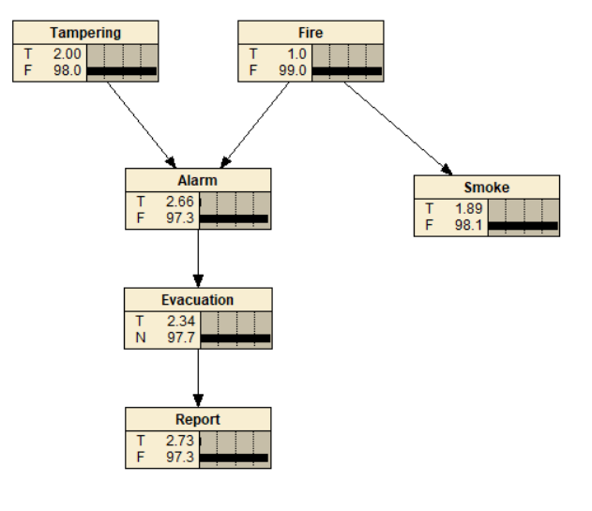Smoke ⊥⊥ Tampering

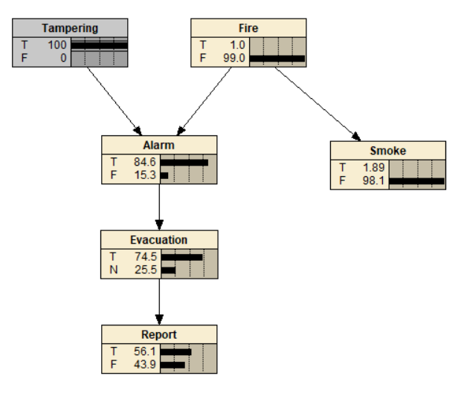Solution: True, Tampering and smoke are independent because tampering and fire anre independent due to no common effect and since smoke is dependent on fire since fire is the cause of smoke. So smoke is also independent of tampering as fire is also independent of tamering. Using Netica it has been verified as we can see that any change in tampering is not been propagated to smoke.

Smoke ⊥⊥ Tampering | Alarm

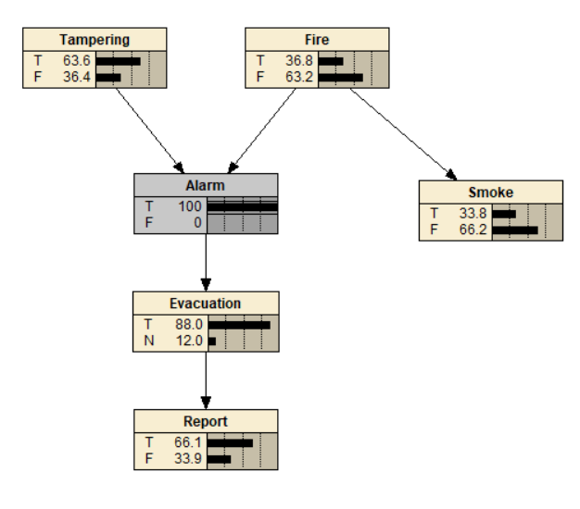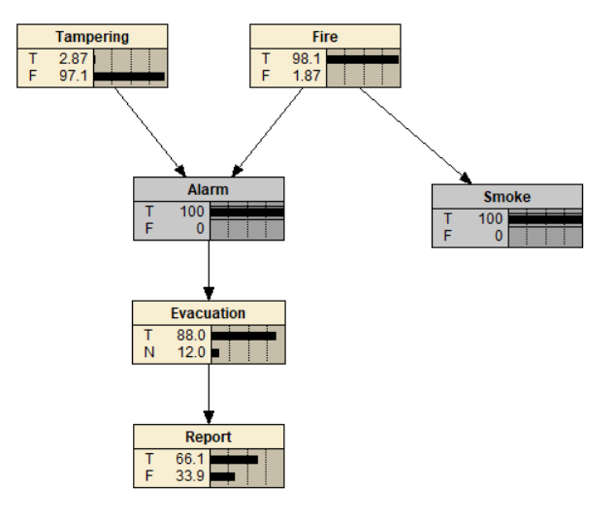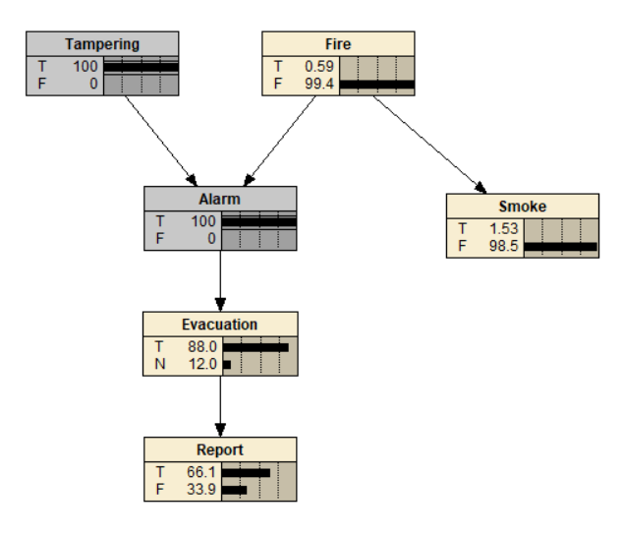

Solution: False, Smoke and tampering are now dependent because now tampering and Fire are dependent due to common effect and fire is dependent on smoke as they both part of same chain. Using Netica we can see that any change in smoke is been propagated to Tampering and vice versa

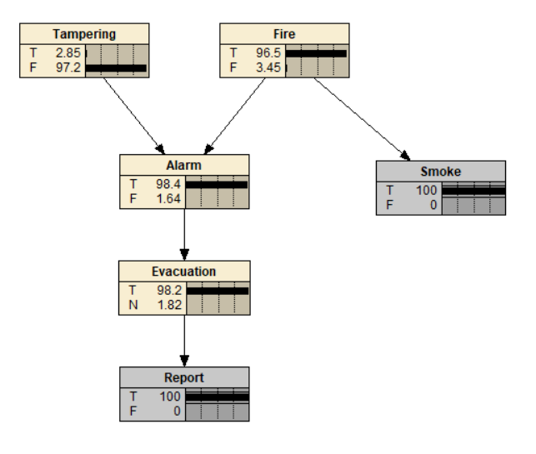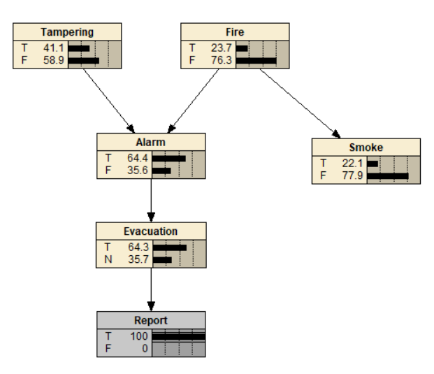Smoke ⊥⊥ Tampering | Report

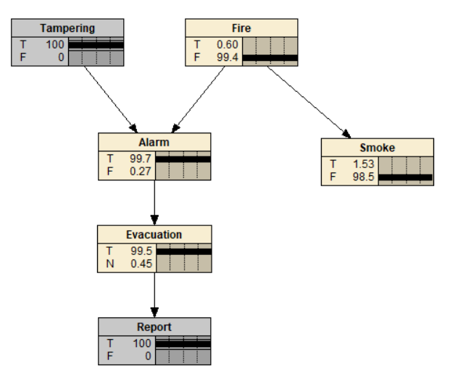Solution: False, Smoke and Tampering are dependent because report and alarm are dependent since both are part of chain. Now tampering and fire are dependent due to common effect. Since fire and smoke are part of a chain they both are dependent hence tampering and smoke are dependent. Using Netica we can see that any change in tampering is been propagated to smoke and vice versa.

(d) Based on your BN, construct a Bayesian Decision Network (BDN) that decides whether the building should be evacuated. That is, instead of having an Evacuation chance node, you should have a decision node that determines whether you should evacuate the building. Specify and justify the information links and the values in the utility node. BDNs without justifications will receive no marks.

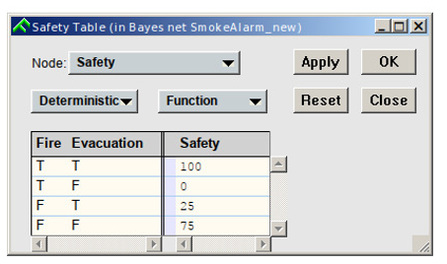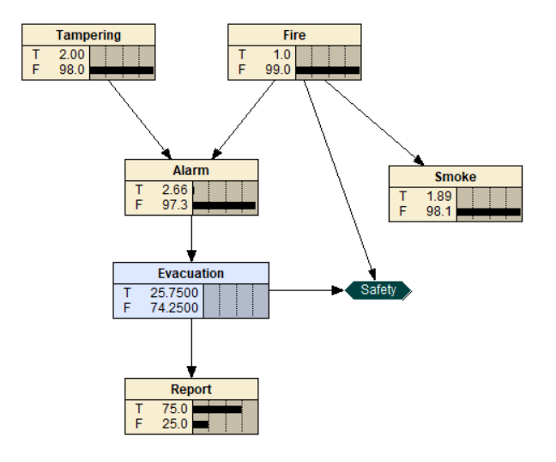

The links and utility values are justified as follows:

Firstly, we are only concerned with whether a fire has occurred and whether we have evacuated the building. As a result, the utility node is only connected to ‘Evacuation’ and ‘Fire’. We assume that the Evacuate node is connected only to the alarm node, as is the case in the earlier questions. This is how an automated system would function.

We assume an evacuation has some small cost (we would not want people having to evacuate every day) if we do it when there is no fire. However, we also assume that the worst case possible is a false negative (no evacuation when there is a fire could lead to deaths).

This leads to the following weights:

Firstly, evacuating when there is a alarm receives the maximum weight of 100 as it is very important to avoid any deaths.

Secondly, avoiding evacuations when there is no alarm is good so we can avoid inconvenience, receiving the second highest weight of 75.

Thirdly, we want to assign some penalty to false alarms (evacuating without an alarm), so we give it the third highest weight of 25.

Finally, we assign the lowest value of 0 to a false negative, where we fail to evacuate the building given that we have seen a fire.

This set of weights, tested in Netica, has the property that we assign not evacuating a higher value than evacuating in the absence of other information. If we observe an alarm, this system dictates we evacuate. If smoke is observed, the system also dictates we evacuate. Observing a fire also causes an evacuation to occur, regardless of the state of other nodes. Finally, observing an alarm alongside tampering results in no evacuation, so the network effectively accounts for the fact that tampering makes the alarm unreliable.

**Question 2**

2)It is coming to the end of winter and Ron is trying to model the factors that affect the state of his lawn. The lawn is currently looking pretty sad, as his children spent all last summer playing backyard cricket, and have worn several bare patches. However, the area has been in drought for the previous 12 months. If there is no rain before summer, it will be very hard to get the new lawn to grow, and Ron will waste a lot of time and money. Furthermore, if there is no rain, the authorities could increase the level of water restrictions, meaning that Ron will be unable to water his lawn at all. This would make the chances of his lawn surviving very small indeed. To further complicate the matter, there is a small chance that the area could experience another frost before the weather warms up, which also could damage the new lawn.

(a) Design a BN using the nodes: Rain, LawnGrow, WaterRestrictions and Frost. Justify your design. A BN without justification will receive no marks.

(b) Inspect your BN and report on any value assignments that will cause d-separation between any sets of nodes. Explain why this is the case. Value assignments without explanations will receive no marks.

(c) Quantify the relationships in the network by adding numbers for the CPTs. Justify the numbers in your CPTs. CPTs without justification will receive no marks.

(d) Using Netica, demonstrate the workings of your BN by determining the probability of the lawn growing in the following cases.

1. There is no evidence.

2. There is no rain, and water restrictions have been applied. Explain your results compared to item 1.

3. There is frost, but it has rained. Explain your results compared to item 1.

**Question 3**

Consider the following Bayesian Network called rental2.dne (available on moodle).

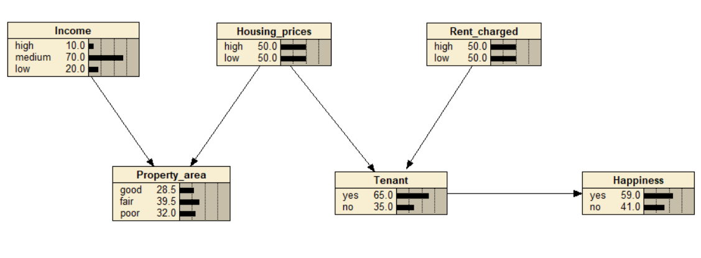

1. List the conditions under which you will be able to propagate evidence from Income to Rent charged. That is, which nodes need to be instantiated or uninstantiated so that evidence can be propagated from Income to Rent charged. Explain why this is the case.

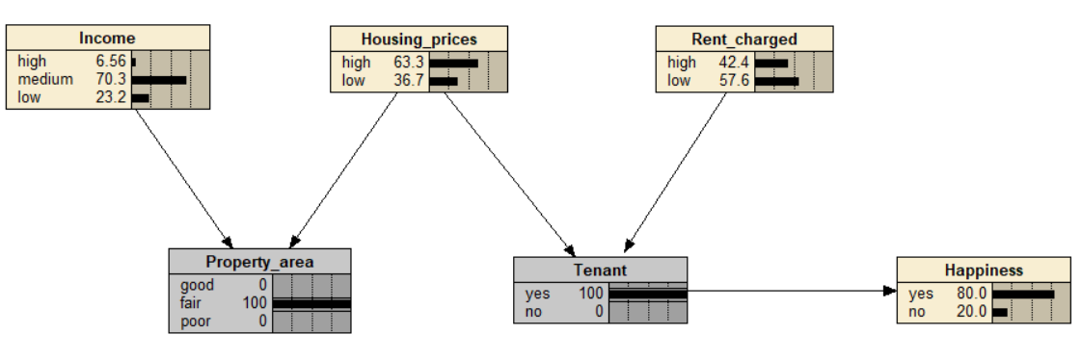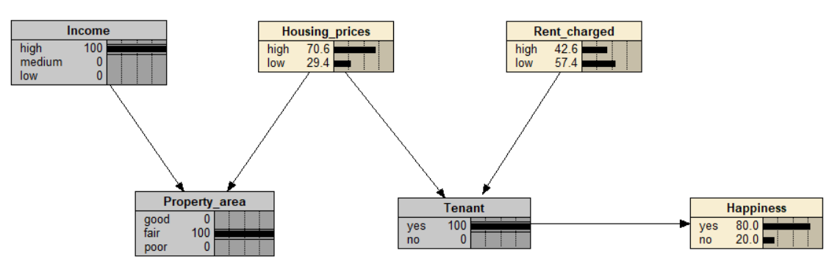

Initially income and housing prices was independent due to no-common effect but once property_area is been instantiated it becomes dependent based on the common effect. So now the changes made in income is been propagated to housing_price but it still won’t reach rent charged as housing process and rent charged have non common effect and thus they are independent. But once the tenant is been instantiated then the housing prices and the rent charged becomes dependent based on the common effect. Hence from now onwards the changes is income propagates to housing prices which eventually propagates to the rent charged

1. Repeat question (a) for propagating evidence from Happiness to Property area (with explanations).

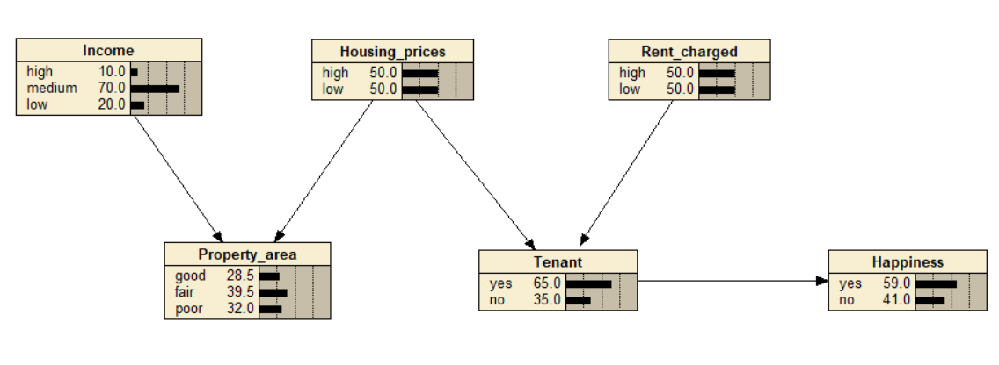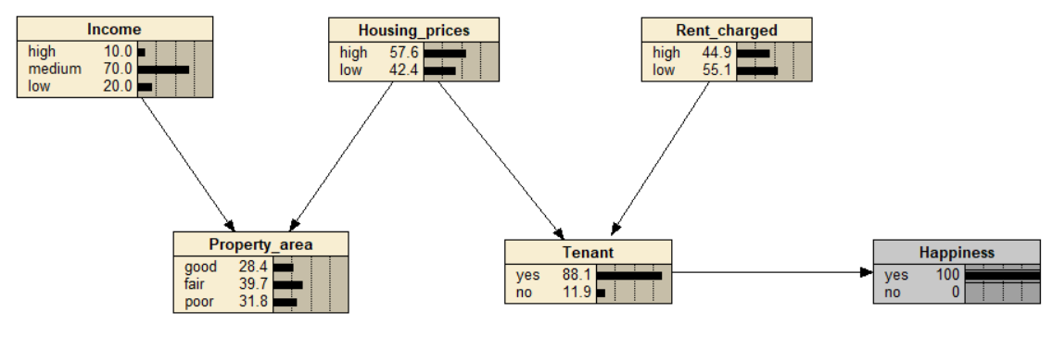

Without any instantiating or uninstantiating, happiness and property area are dependent that is any change in happiness is been propagated to property area because happiness and housing prices are dependent because they are a chain and since housing price is a cause for property area so any change in housing price results in change in property area. Or is other words Housing price acts as a common cause for both Happiness and property area so eventually any change in happiness is been propagated to property area.

1. Repeat the above questions under the assumption that there is also an arc from Property area to Tenant (the corresponding BN, rental3.dne, is available on moodle). Compare your results with those obtained above.

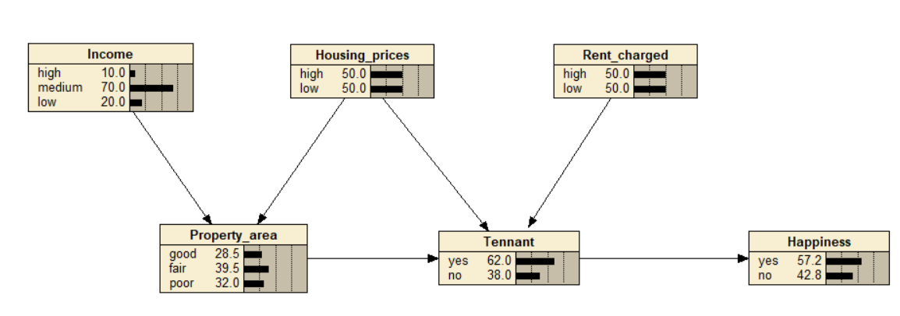

Case: Income to rent charged

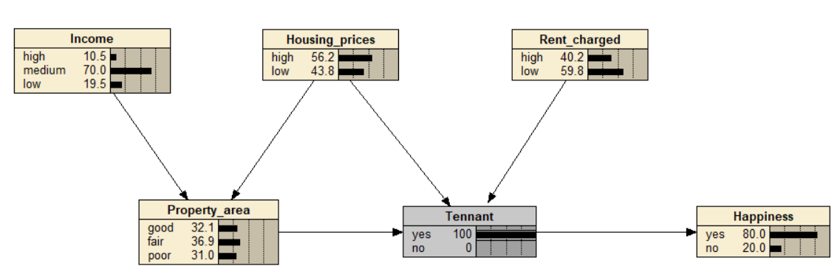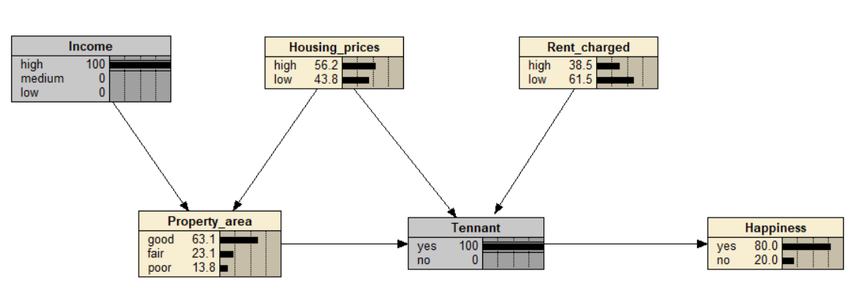

Here any change in income doesn’t propagate to rent charged because at tenant both of then acts like a no common effect d separation and thus they are independent. But once the tenant is being instantiated any change in income is been propagated to rent charged due to common effect.

Case: Happiness to property area

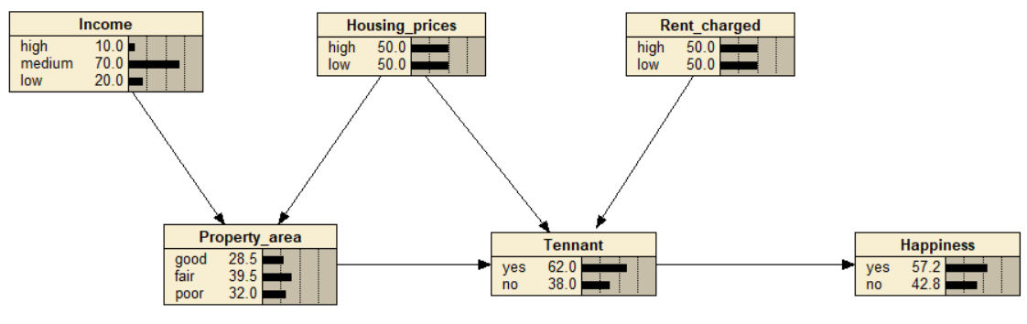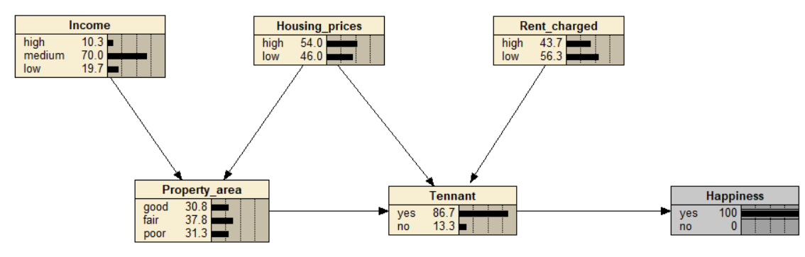

Here any change in happiness is directly been propagated to property area because they both are in chain